**PROJECT DESIGN PHASE-II**

**TECHNOLOGY STACK (ARCHITECTURE & STACK)**

|  |  |
| --- | --- |
| **Date** | **15 .10.2022** |
| **Team ID** | **PNT2022TMID41966** |
| **Project Name** | **IoT Based Smart Crop Protection System For Agriculture** |

**Technical Architecture:**

**The Deliverable shall include the architectural diagram as below and the information as per the table1 & table**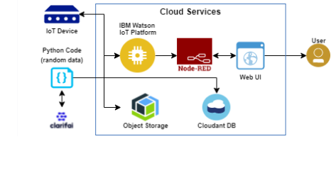

**Table 1: Components & Technologies:**

|  |  |  |  |
| --- | --- | --- | --- |
| **S. No** | **Component** | **Description** | **Technology** |
| **1.** | User Interface | How user interacts with the Web UI | App development |
| **2.** | Application Logic-1 | Logic for a process in the application | Python Objectives |
| **3.** | Application Logic-2 | Logic for a process in the application | IBM Watson STT service |
| **4.** | Application Logic-3 | Logic for a process in the application | Node-RED service |
| **5.** | Database | Data Type | Database Cloudant DB |
| **6.** | Cloud Database | Database Service on Cloud | Cloud Object store service |
| **7.** | File Storage | File storage requirements | IBM Block Storage |
| **.** | Infrastructure (Server / Cloud) | Application Deployment on Local System / Cloud Local Server Configuration:  Cloud Server Configuration: | Cloud Foundry |

|  |  |  |  |
| --- | --- | --- | --- |
| **S. No** | **Characteristics** | **Description** | **Technology** |
| 1. | Open-source Frameworks | The open-source frameworks used | SAN-SAF |
| 2. | Security Implementations | List all the security / access controls implemented | IBM cloud encryptions |
| 3. | Scalable Architecture | Justify the scalability of architecture (3 – tier,  Micro-services) | IBM cloud Architecture |
| 4. | Availability | Justify the availability of applications (e.g. use of load balancers, distributed servers etc.) | Web Application can even be used by the framers in the horticulture |
| 5. | Performance | Design consideration for the performance of the application | Since the web application is highly efficient, it can be used by the farmers irrespective of time. |